Comparison of ATP–POC Relationships Along Coastal–Estuarine Transects in the Chesapeake Bay Region

Hunter Swann
Department of Oceanography, Old Dominion University
OEAS 455W/551: Data Collection and Analysis in Oceanography
Dr. Alexander Bochdansky
April 27, 2026

Abstract:
Measuring living microbial biomass in the ocean can get difficult because most bulk measurements include both living cells and non-living material. ATP is used as an indicator of living biomass, while particulate organic carbon (POC) represents total particulate material. This study looks at the relationship between ATP and POC along coastal–estuarine transects in the Chesapeake Bay region using data collected on the RV Fay Slover in June 2019 and April 2024. Linear regression showed a positive relationship between ATP and POC in both years.
An analysis of covariance (ANCOVA) was used to test whether the ATP–POC slopes were different between years. A permutation randomization test (10,000 iterations) was also used to support the results without solely relying on statistical estimates. The results showed no significant difference between years (F = 0.1455, p = 0.68; permutation p = 0.7089). Resulting in the ATP–POC relationship stayed consistent across both sampling periods.
Overall, the results showed a stable relationship between microbial biomass (ATP) and particulate organic carbon, in coastal and estuarine environments.

Introduction:
Microbial biomass in the ocean plays a very important role in carbon cycling, nutrient regeneration, and ecosystem functioning (Karl & Church 2014). Measuring living biomass in marine systems remains difficult. Particulate organic carbon (POC) is commonly used as a proxy for biomass; however, POC includes both living microorganisms and non-living detrital material, which can make estimates of active biological processes (Bochdansky et al. 2024). Adenosine triphosphate (ATP) is found in all living cells and represents metabolically active biomass (Holm-Hansen, 1970). Unlike POC, ATP reflects living microbial material and is less affected by detritus. This study investigates the relationship between ATP and POC along coastal–ocean transects sampled aboard the research vessel Fay Slover during June 2019 and April 2024 in the Chesapeake Bay region. These datasets show comparison across spatial gradients and between years. The primary goal of this study is to determine whether the relationship between ATP and POC changes significantly between 2019 and 2024. The hypothesis is that the ATP–POC relationship will differ significantly between years due to changes in environmental conditions and microbial community structure.

Methods:
Field sampling
Seawater was collected aboard the RV Fay Slover using 5 L Niskin bottles along a coastal–estuarine gradient from the Chesapeake Light Tower into Chesapeake Bay during June 2019 and April 2024. Samples were obtained across multiple stations and depths representing open-ocean to estuarine conditions (Bochdansky et al. 2024).
ATP measurement
Particulate ATP was extracted using a hot-water chemical extraction following filtration onto GF/F filters. Filters were preserved in PBAC solution and frozen at −80 °C prior to analysis. ATP concentrations were determined using a luciferin–luciferase assay measured by scintillation counting. Triplicate measurements were averaged (Bochdansky & Rauch 2026).
Particulate organic carbon (POC)
Seawater samples were filtered onto pre-combusted GF/F filters and analyzed using a CHN elemental analyzer. POC values were measured as single samples (Bochdansky et al. 2024).
Data processing
- 2019 and 2024 datasets were compiled separately.
- 2024 POC values were converted from mg L⁻¹ to µg L⁻¹ for consistency.
- Non-detects and missing values were removed (NaN filtering).
- Final datasets included multiple stations and depths (2019: 4 stations; 2024: 5 stations).

Statistical analysis
ATP–POC relationships were evaluated using linear regression. An analysis of covariance (ANCOVA) tested whether regression slopes differed between years. A permutation randomization test assessed statistical significance under relaxed distributional assumptions (α = 0.05).

Results:
ATP–POC Relationships
ATP and POC exhibited positive linear relationships in both sampling years (Figure 1). In 2019, there was a strong linear coupling with relatively low scatter. In 2024, the positive relationships remained but showed increased variability among stations and depths. Coefficient of determination values indicated strong ATP–POC coupling in both datasets, though variability increased in 2024.

Figure 1: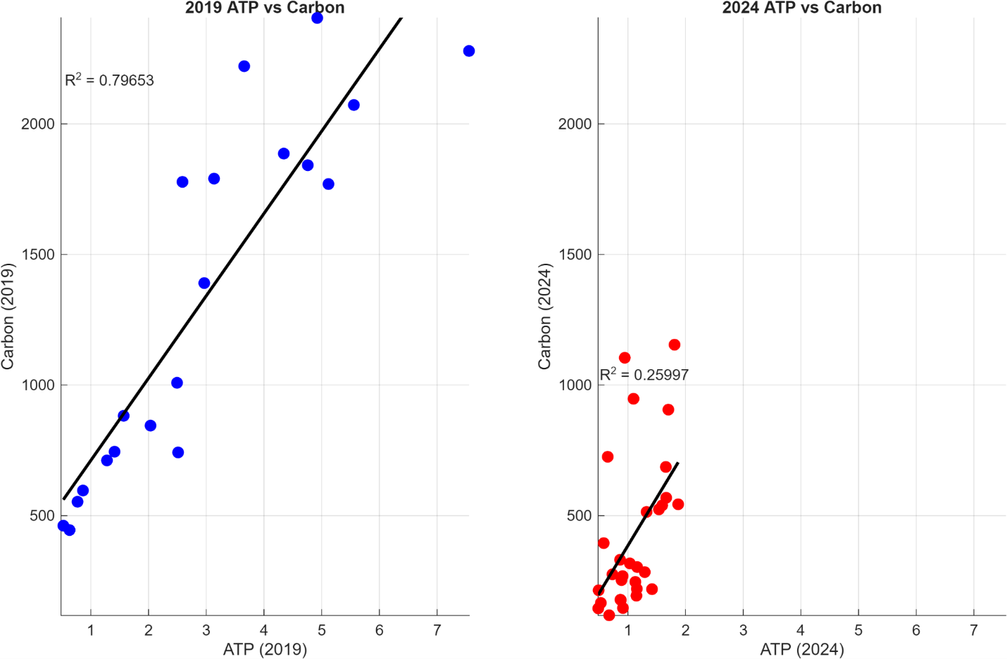
Figure 1. Relationship between particulate ATP and particulate organic carbon (POC) measured along coastal–estuarine transects in the Chesapeake Bay region. (a) June 2019 observations show a strong linear relationship between ATP and POC (n = 20, R² = 0.797, F = 70.5, p = $1.23 X {10}^{-7}$). The regression equation is POC = 396.4 + 315.11(ATP). (b) April 2024 observations exhibit a similar positive relationship but with increased variability (n = 30, R² = 0.26, F = 9.84, p = 0.004). The regression equation was: POC = 19.964 + 365.46(ATP)
Statistical comparison (ANCOVA)
An analysis of covariance (ANCOVA) was performed to test whether the relationship between ATP and particulate organic carbon differed between sampling years.
The null hypothesis (H₀) stated that the slopes of the ATP–POC relationships were equal between 2019 and 2024, indicating no change in the relationship between living microbial biomass and particulate carbon.
The alternative hypothesis (H₁) proposed that the slopes differed between years.
Permutation testing was used to evaluate significance without assuming normality. The observed test statistic was F = 0.1455, with a permutation p-value = 0.68.
Because p ≥ 0.05, the null hypothesis cannot be rejected, indicating that the ATP–POC relationship did not change significantly between 2019 and 2024.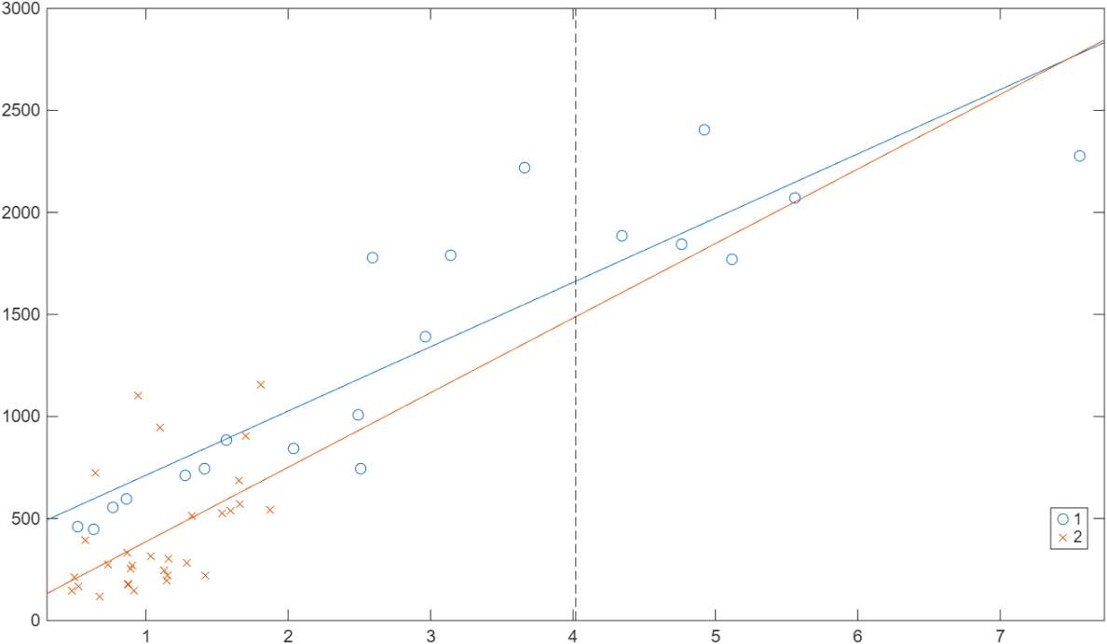
(Figure 2: ANCOVA Prediction Plot)
The ANCOVA prediction plot shown above is comparing ATP–POC regression relationships between June 2019 and April 2024 sampling periods, showing similar slopes between the two years. Regression lines represent modeled ATP–POC relationships after accounting for variance explained by the covariate. The nearly parallel slopes indicate that the relationship between metabolically active biomass (ATP) and particulate organic carbon remained consistent between years. The low test statistic (F = 0.1455) and high permutation p-value (p = 0.68) demonstrate that differences between fitted regression lines are small relative to within-dataset variability. These results indicate that interannual environmental differences altered scatter within the datasets but did not significantly modify the underlying biomass–carbon coupling.
A permutation randomization test using 10,000 iterations produced a p-value of 0.7089, confirming the ANCOVA result and indicating no statistically significant difference between slopes (Figure 3).
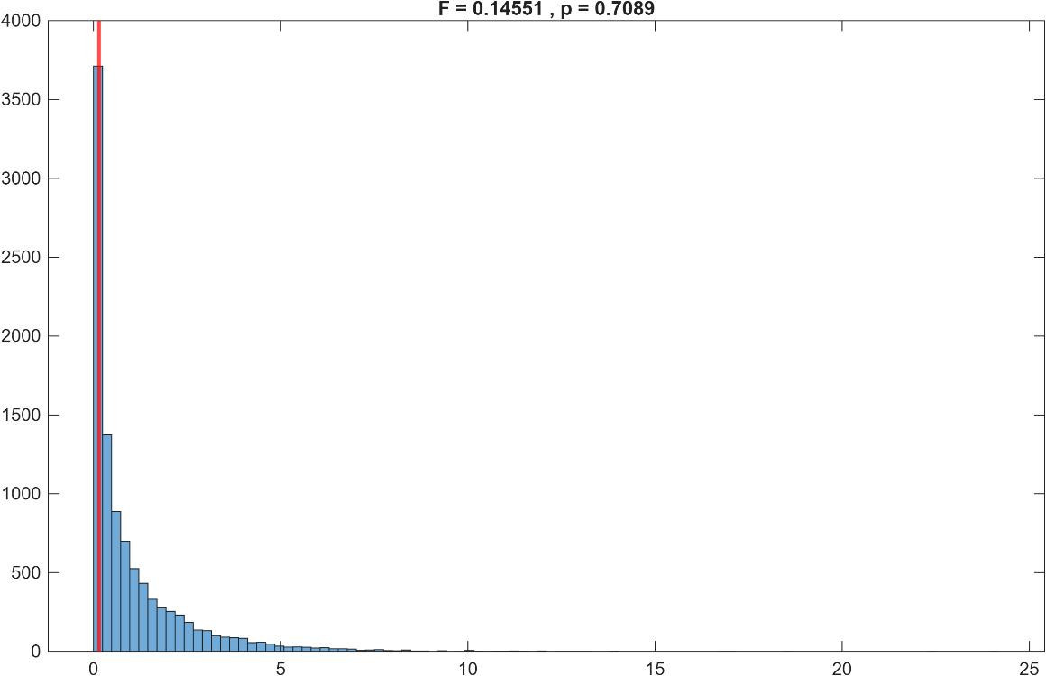

Figure 3 shows distribution of randomized F statistics generated from 10,000 permutation iterations used to evaluate statistical significance without assuming normal data distributions. Each permutation randomly reassigned observations among years to simulate outcomes expected if no true difference in ATP–POC slopes existed. The observed F statistic lies well within the central region of the null distribution rather than in the extreme tail, indicating that the measured difference between years is consistent with random sampling variability. The resulting permutation p-value (p = 0.7089) independently confirms the ANCOVA result, providing robust statistical evidence that ATP–POC relationships did not differ significantly between 2019 and 2024.
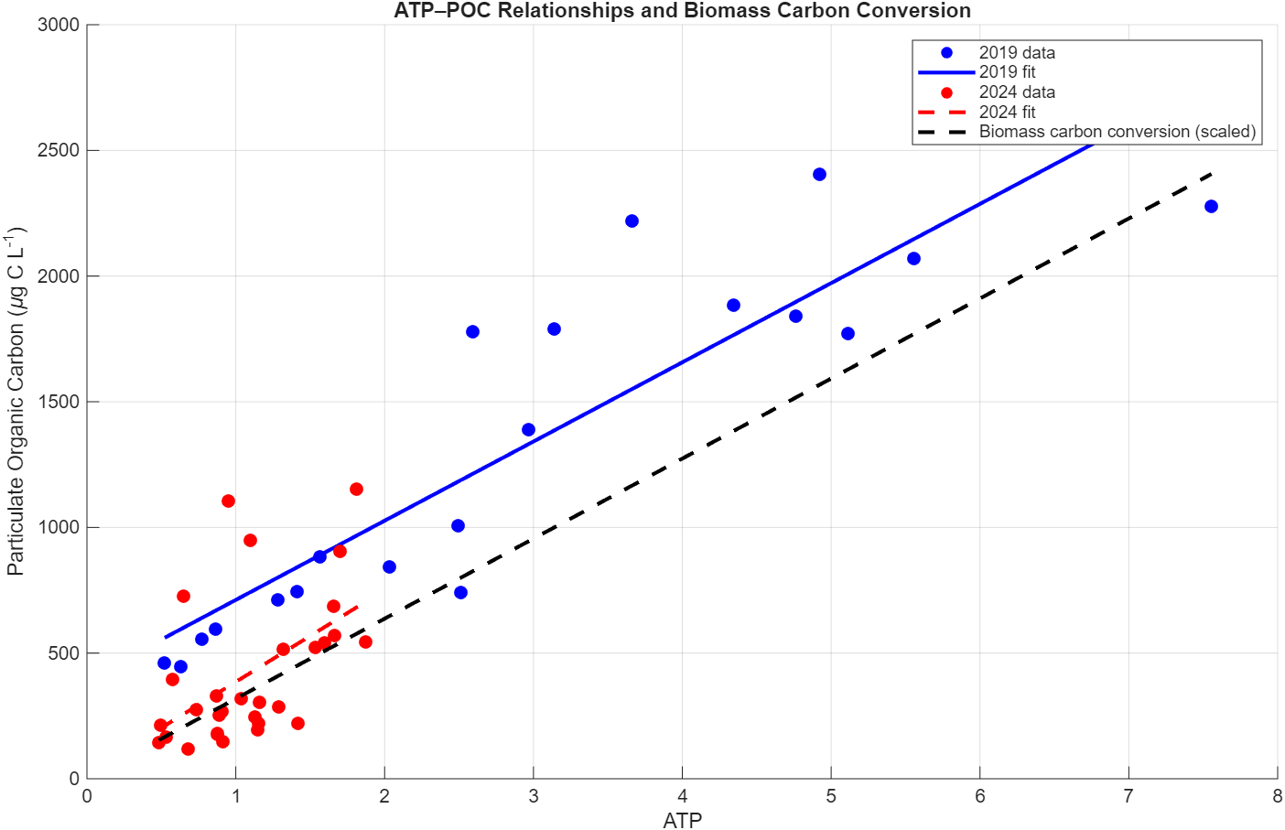
ATP concentrations were converted to biomass carbon (µg C L⁻¹) using a conversion factor of 507.18 to obtain µg ATP followed by multiplication by 250 to estimate carbon equivalents (Holm-Hansen, 1970). The resulting biomass carbon (µg C L⁻¹) estimates were plotted against measured ATP concentrations for the combined dataset (Figure 4).
The ATP-derived biomass carbon estimates followed the overall trend of measured particulate organic carbon, indicating that ATP provides a reasonable proxy for living microbial biomass across sampling periods.

Discussion:
The combined ATP–carbon comparison highlights differences in the composition of particulate organic matter between sampling periods. Although both years follow a similar overall biomass–carbon relationship, the June 2019 data show relatively elevated particulate organic carbon compared to ATP-derived biomass. This pattern is better explained by its distinct sampling location, as the June 2019 measurements extended deeper into the estuary, where both ATP and particulate carbon were higher. Particulate organic carbon measurements include both living microbial biomass and suspended detritus, whereas ATP primarily reflects metabolically active organisms. Higher particulate organic carbon concentrations are better explained by sampling farther into the estuary, where both microbial biomass and total particulate material were elevated relative to the offshore stations. Long-term observations from Station ALOHA demonstrate that temporal variability in particulate carbon pools is often driven by fluctuations in detrital accumulation rather than changes in microbial biomass itself (Karl et al., 2022). In contrast, the April 2024 observations exhibit closer agreement between ATP-derived carbon and bulk POC, indicating a larger proportion of actively living biomass within the particulate carbon pool during spring conditions in the Chesapeake Bay region.
The results show a clear positive relationship between ATP and particulate organic carbon throughout both sampling years. Even with differences in sampling season and environmental conditions, statistical analysis suggests that the coupling between living microbial biomass (ATP) and bulk particulate carbon remained consistent.
The lack of a significant difference between years (p = 0.68) suggests that the relationship between ATP-derived living biomass and total particulate organic carbon remained similar across sampling periods. While visual representation of the 2024 dataset shows more scatter, this variability does not represent a major change in the ATP–POC relationship.
Seasonal differences between June 2019 and April 2024 may affect productivity, nutrient availability, and microbial community structure. Microbial biomass and biogeochemical processes in marine systems are known to be different across the multiple temporal and spatial scales, particularly in dynamic coastal environments where physical and biological conditions change rapidly (Karl & Church 2014). However, these factors seem to influence the amount of variability rather than alter the underlying relationship between ATP and particulate carbon.
Overall, the persistence of the ATP–POC relationship supports the use of ATP as a useful proxy for living microbial biomass in dynamic coastal ocean environments like the Chesapeake Bay.
These results highlight the importance of separating living microbial biomass from bulk organic matter when studying marine carbon cycling. The stability of ATP–POC relationships across different seasonal conditions suggests that microbial biomass scales are fairly predictable with particulate carbon in these systems. Future studies that include environmental factors such as nutrients, temperature, and phytoplankton processes may further help understand and explain the sources of variability within this relationship.

References:
Holm-Hansen, O. (1970). ATP levels in algal cells as influenced by environmental conditions. Plant and Cell Physiology, 11(5), 689–700. https://doi.org/10.1093/oxfordjournals.pcp.a074557

Bochdansky AB, Beecher AA, Calderon JR, Stouffer AN, Washington NN (2024) A comparison of adenosine triphosphate with other metrics of microbial biomass in a gradient from the North Atlantic to the Chesapeake Bay. Front Mar Sci 11:1288812.

Bochdansky AB, Rauch S (2026) CTD data and particulate organic carbon, particulate organic nitrogen, and adenosine triphosphate from Niskin bottle samples collected along the coastal ocean off Virginia Beach into the Chesapeake Bay aboard RV Fay Slover on April 1, 2024. 1:6.

Karl DM, Church MJ (2014) Microbial oceanography and the Hawaii Ocean Time-series programme. Nat Rev Microbiol 12:699–713.

Karl DM, Björkman KM, Church MJ, Fujieki LA, Grabowski EM, Letelier RM (2022) Temporal dynamics of total microbial biomass and particulate detritus at Station ALOHA. Prog Oceanogr 205:102803. https://doi.org/10.1016/j.pocean.2022.102803

